**TENSORFLOW GPU WITH CUDA NVIDIA INSTALLED IN WINDOWS, FOLLOW THIS YOU TUBE VIDEO**

<https://www.youtube.com/watch?v=ZYR9gqxAhXo&t=10s>

**PYTORCH GPU WITH CUDA NVIDIA INSTALLED IN WINDOWS, FOLLOW THIS YOU TUBE VIDEO**

<https://www.youtube.com/watch?v=kmuCadPH34w>

|  |  |  |
| --- | --- | --- |
| **COMMAND** | **USED FOR** | |
| pip list | | Check Installed packages are available |
| conda info –envs | | Check Virtual Environment are available |
| (base) C:\Users\user>python -V | | Check Python Version Available |
| conda create -n cuda_tf python=3.9 | | Create Virtual Environment |
| (base) C:\Users\user>conda activate cuda_tf | | Activate Virtual Environment |
| (cuda_tf) C:\Users\user>python  >>> import tensorflow as tf  >>> tf.__version__  >>> tf.test.is_gpu_available()  OR  >>> tf.config.list_physical_devices('GPU')  [PhysicalDevice(name='/physical_device:GPU:0', device_type='GPU')]  IF NOT AVAILABLE THEN SHOW []  IF TWO GPUS THEN SHOWS [0,1] | | Check whether Tensorflow installed successfully and gpu is also available |
| >>> print ("Num GPUs Available", len(tf.config.experimental.list_physical_devices('GPU')))  *Num GPUs Available 1* | | To show number of GPUs Available in the system |

**DOWNLOAD PYTHON 3.7**

<https://tensorflow-object-detection-api-tutorial.readthedocs.io/en/latest/install.html>

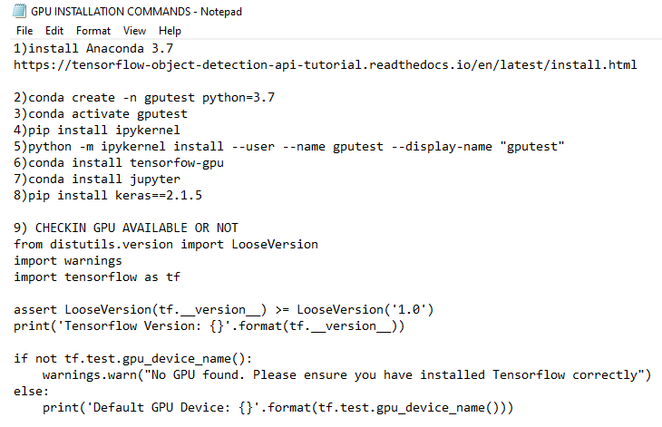

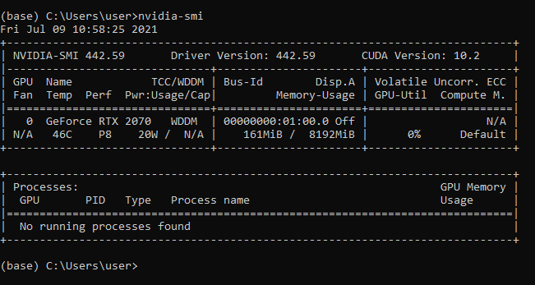

**PKNOT RCAN INSTALLATION**

**First Install Miniconda**

**Than Create Environment**

**Than Install Pytorch through one with CUDA**

**Than Run Text File of PKnot Commands**

|  |
| --- |
| **1)install Anaconda 3.7**  **https://tensorflow-object-detection-api-tutorial.readthedocs.io/en/latest/install.html**  **2)conda create -n gputest python=3.7**  **3)conda activate gputest**  **4)pip install ipykernel**  **5)python -m ipykernel install --user --name gputest --display-name "gputest"**  **6)conda install tensorflow-gpu==1.15 OR**  **conda install tensorflow-gpu**  **7)conda install jupyter**  **8)pip install keras==2.1.5**  **9) pip install opencv-python**  **10)** **pip install matplotlib**  **11) CHECKIN GPU AVAILABLE OR NOT**  **from distutils.version import LooseVersion**  **import warnings**  **import tensorflow as tf**    **assert LooseVersion(tf.__version__) >= LooseVersion('1.0')**  **print('Tensorflow Version: {}'.format(tf.__version__))**    **if not tf.test.gpu_device_name():**  **warnings.warn("No GPU found. Please ensure you have installed Tensorflow correctly")**  **else:**  **print('Default GPU Device: {}'.format(tf.test.gpu_device_name()))** |

**HOW TO CHECK WHICH CUDA VERSION ALREADY AVAILABLE IN LAPTOP**

nvidia-smi

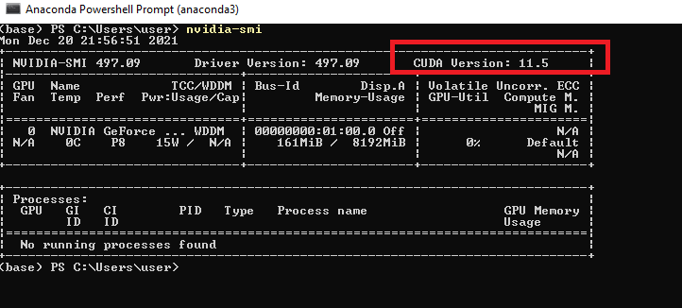

**CHECK ALL VIRTUAL ENVIRONMENT AVAILABLE**

**conda info --envs**

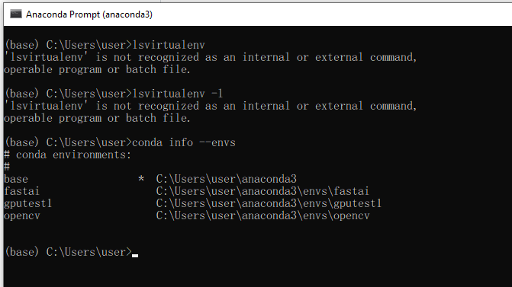

**ACTIVATE AND DEACTIVATE**

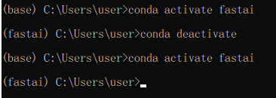

**UNINSTALL UNWANTED JUPYTER KERNEL**

jupyter kernelspec uninstall wazirtest

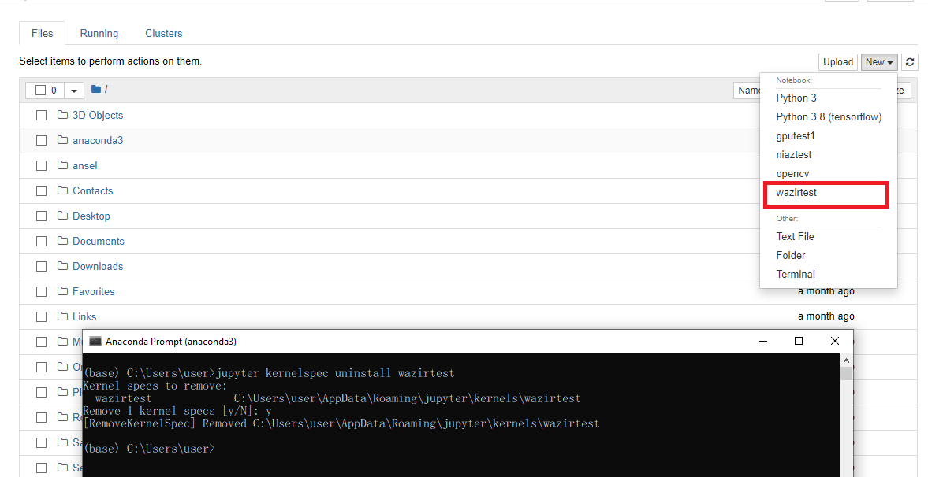

**INSTALL MATPLOTLIB**

conda install -c conda-forge matplotlib

**PYTORCH INSTALLED IN WINDOWS ANACONDA**





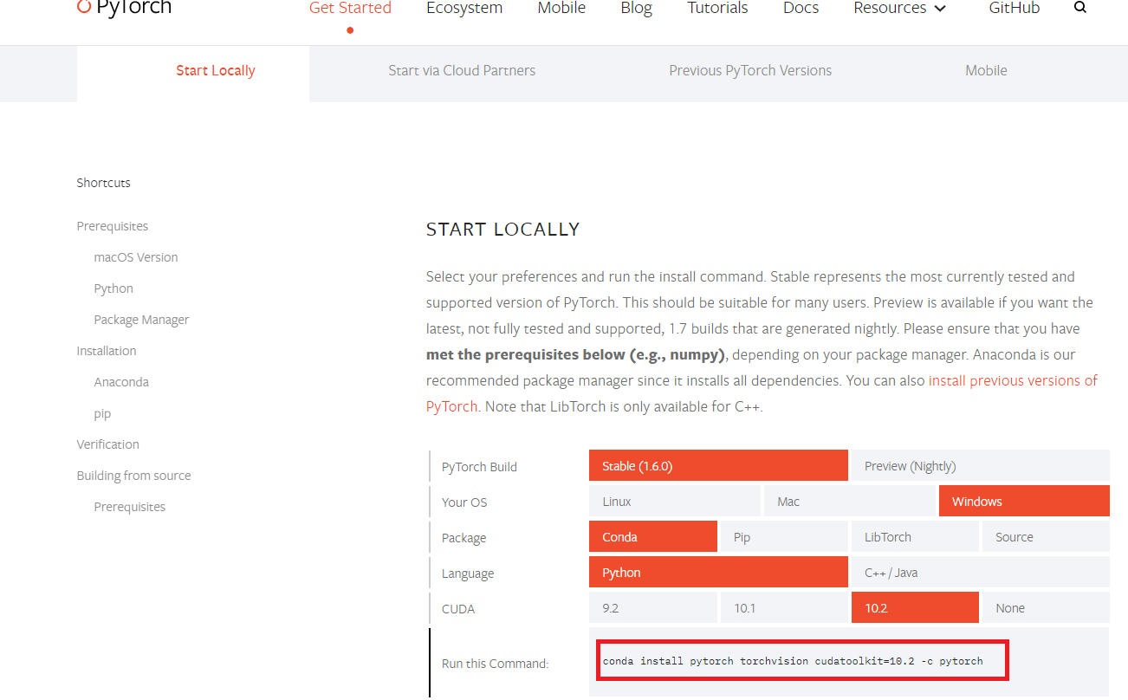

|  |  |
| --- | --- |
|  | pip install tqdm |
|  | (pytorch) D:\IMAGE_SR_TRAINED_MODELS\100_PERCENTR_CORRECT_MODEL\SRCNN_PYTORCH>python  Python 3.7.10 (default, Feb 26 2021, 13:06:18) [MSC v.1916 64 bit (AMD64)] :: Anaconda, Inc. on win32  Type "help", "copyright", "credits" or "license" for more information.  >>> import torch  >>> torch.cuda. is_available()  True |
|  | pip install h5  pip install torchviz |

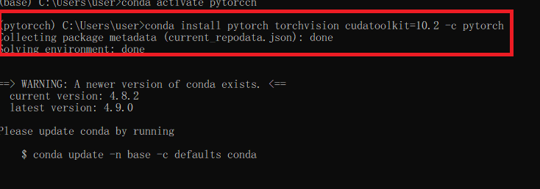

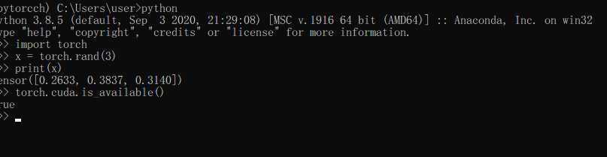

<https://pytorch.org/get-started/locally/>